[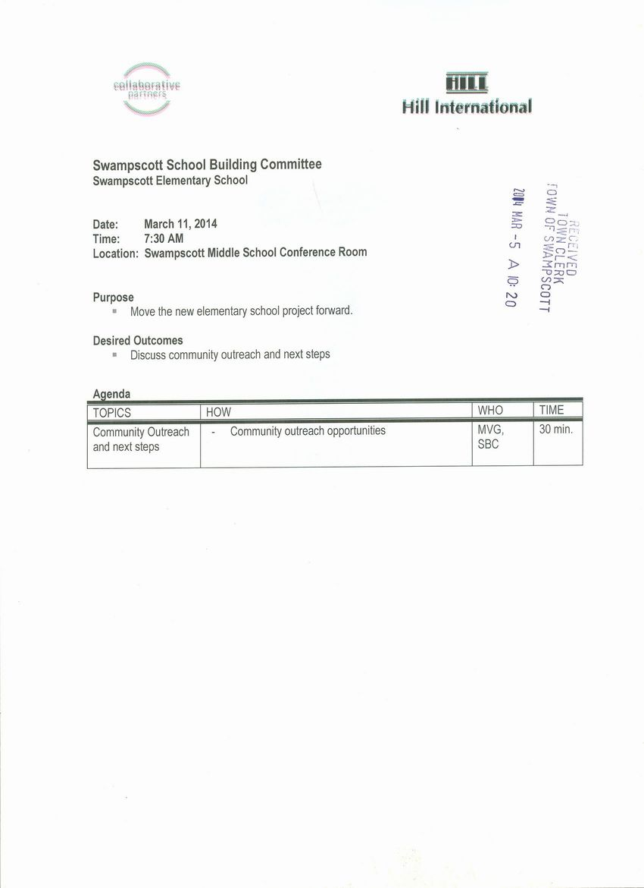](http://www.town.swampscott.ma.us/Public_Documents/SwampscottMA_Calendar/S04660919-04660964.0/School%20Building%20Committee%20March%2011th%20notice%20001.jpg)